Git and git hub -1

Git and Git hub -01
What is Git?
Git is a version control system.
That means:
- It helps you track changes in your code or files over time
- You can go back to previous versions if something breaks
- Multiple people can work on the same project without overwriting each other’s work
What is GitHub?
GitHub is a website/platform that hosts Git repositories online.
That means:
- It stores your Git projects in the cloud
- You can share your code with others
- Teams can collaborate easily
- It provides extra tools (pull requests, issues, code review, etc.)

git init : is used to initialize a new Git repository in your project folder.

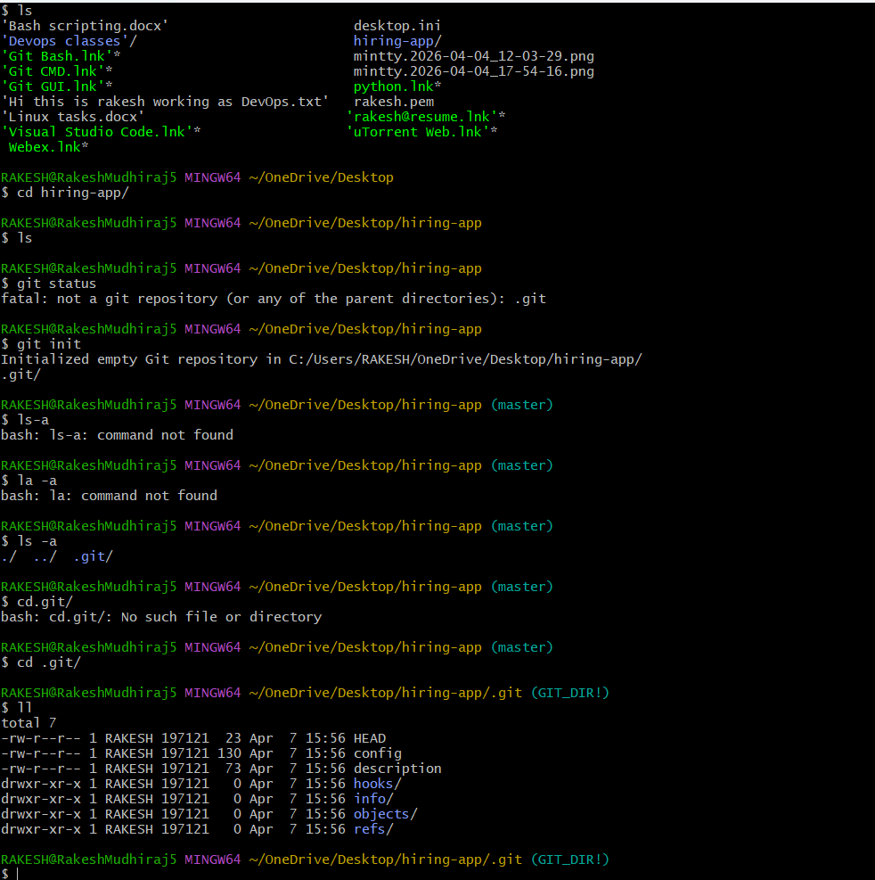

git status: shows the current state of your Git repository.

git config –list: shows all Git configuration settings currently applied.

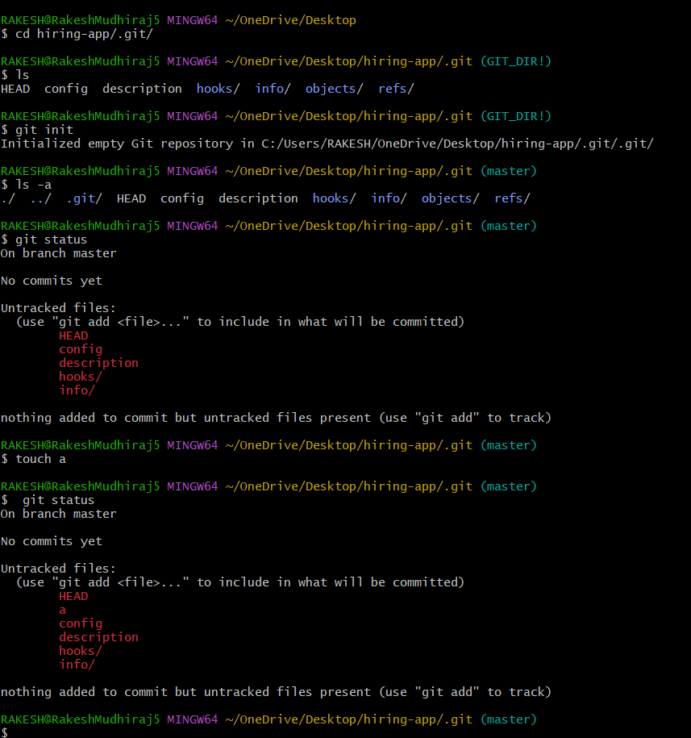

git config –global user.name : Sets your author name for all Git commits

Git config –global user,email : This command is used to set your email in Git globally

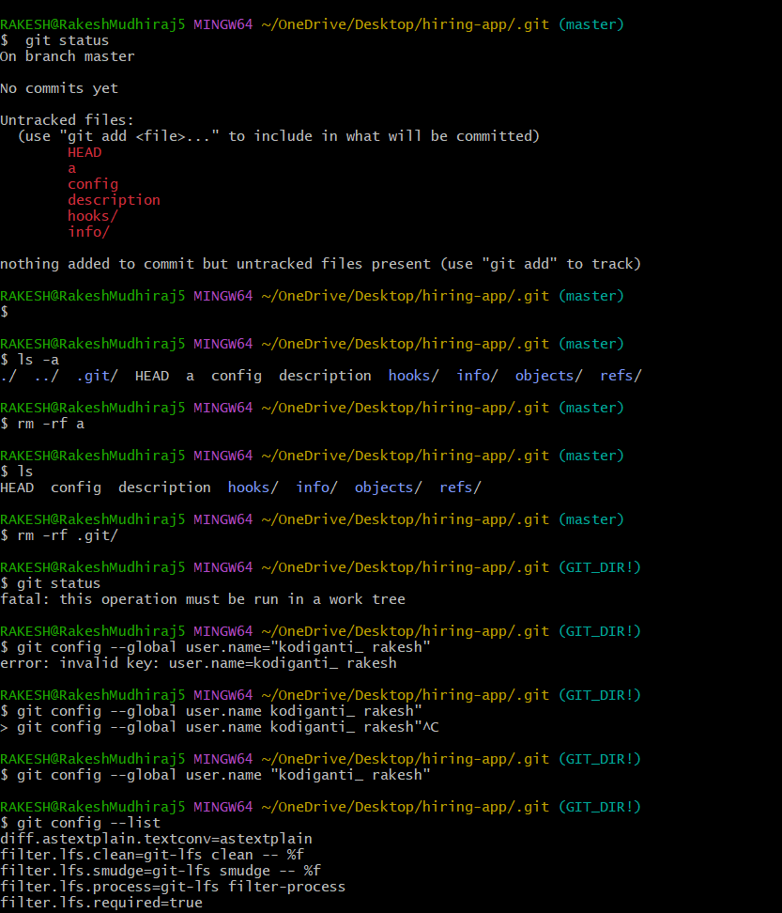

git add filename: is used to add files to the staging area in Git

git add . : adds all changes in the current directory to the staging area.

git commit -m "adding files" : is used to save (commit) your staged changes with a message.

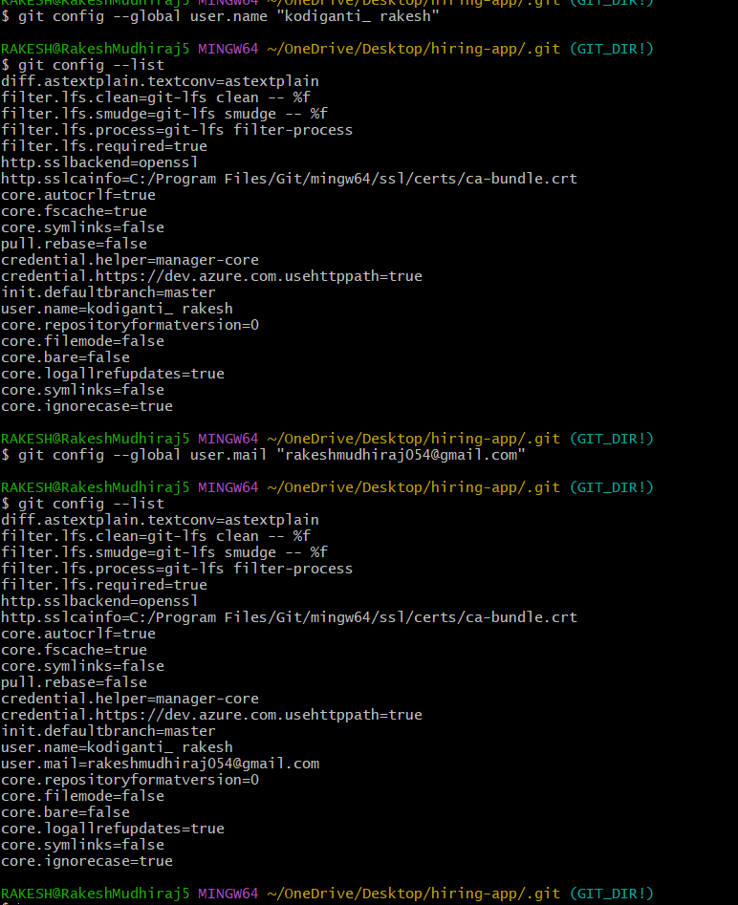
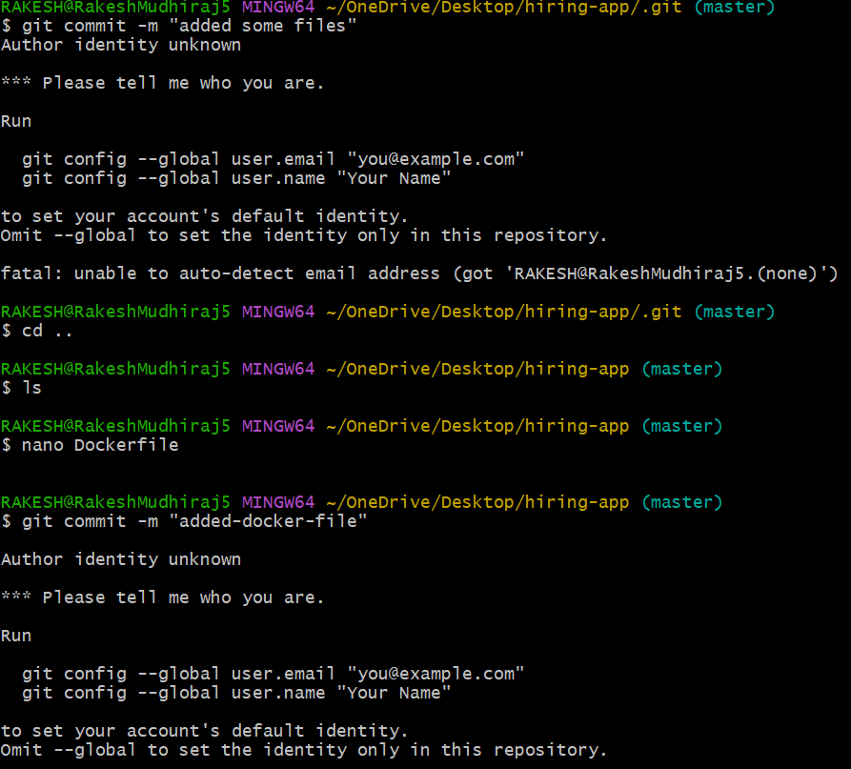

git log : shows the history of commits in your Git repository.
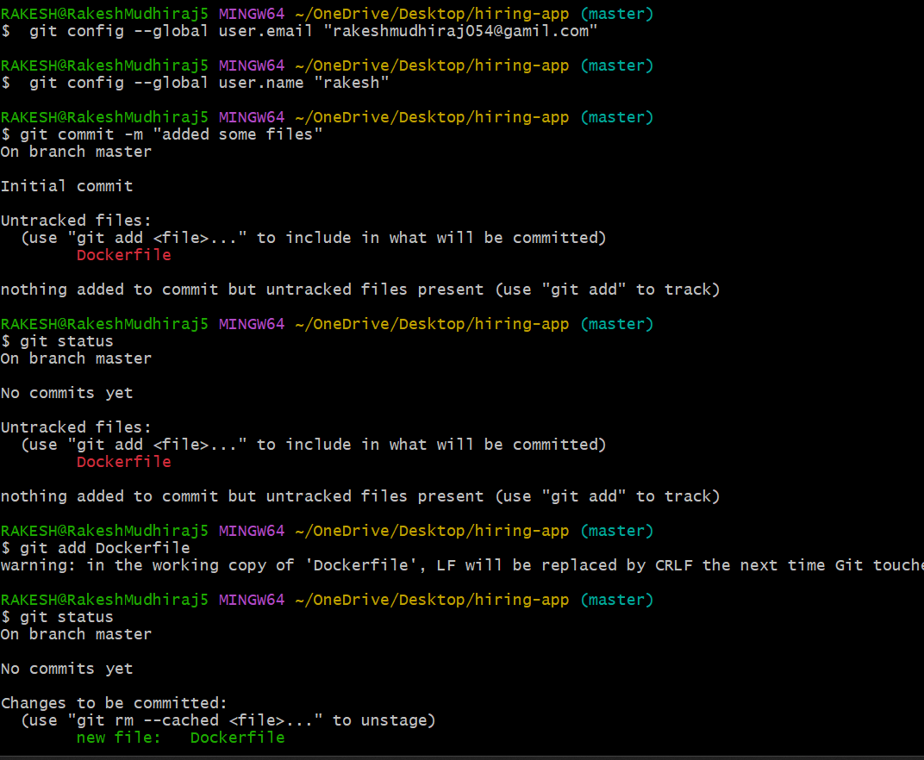
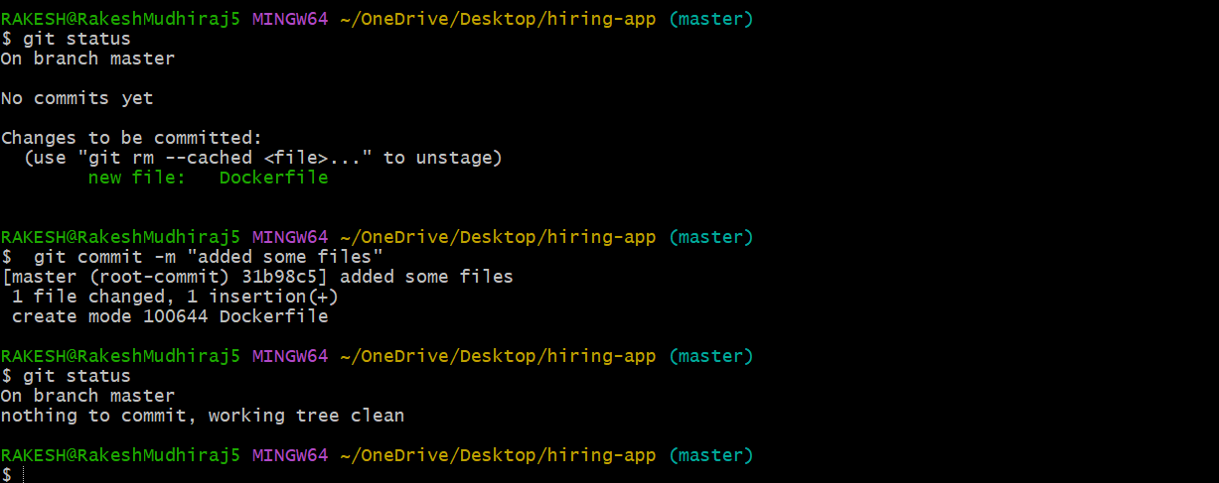

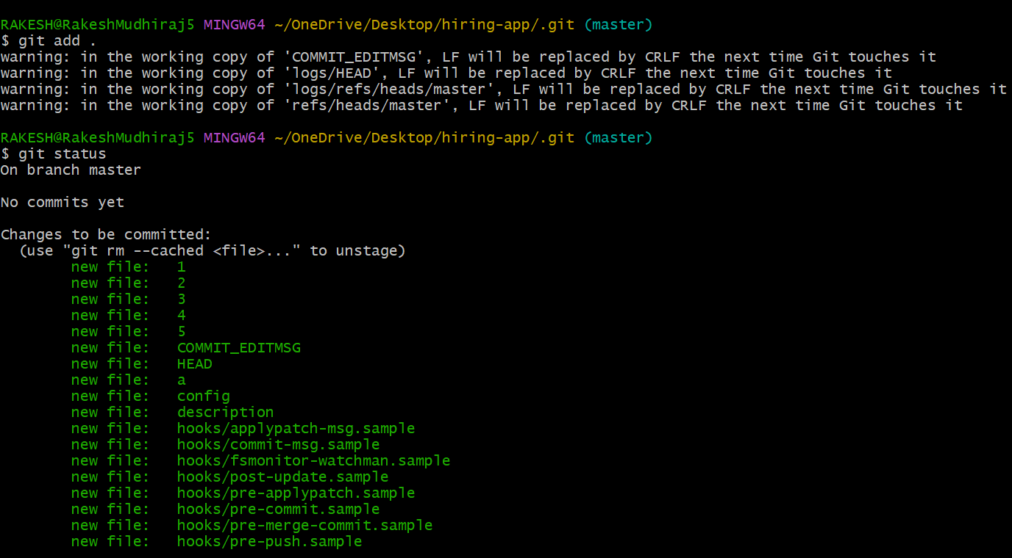

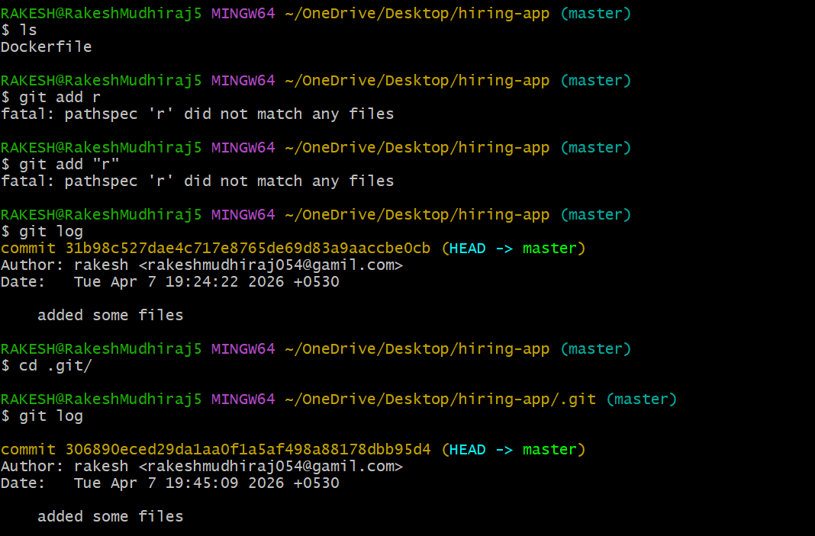

Git remote -v : shows the history of commits in your Git repository.
git remote add origin git@github.com:rakesh-rgp/techie_repo.git

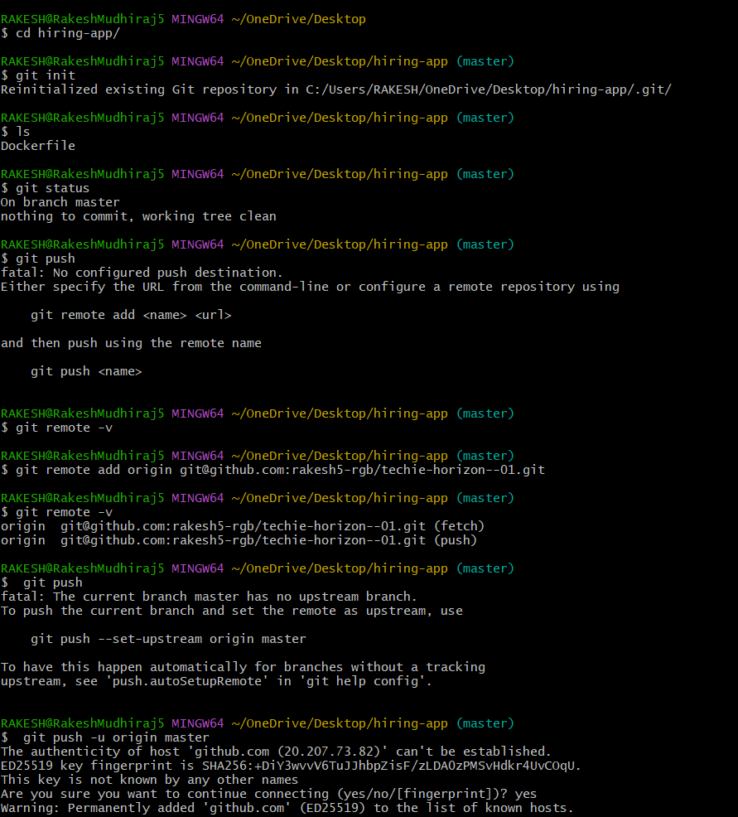

git push -u origin master : is used to upload your local commits to a remote repository (like GitHub
git pull : is used to fetch and download changes from a remote repository (like GitHub) and merge them into your local branch
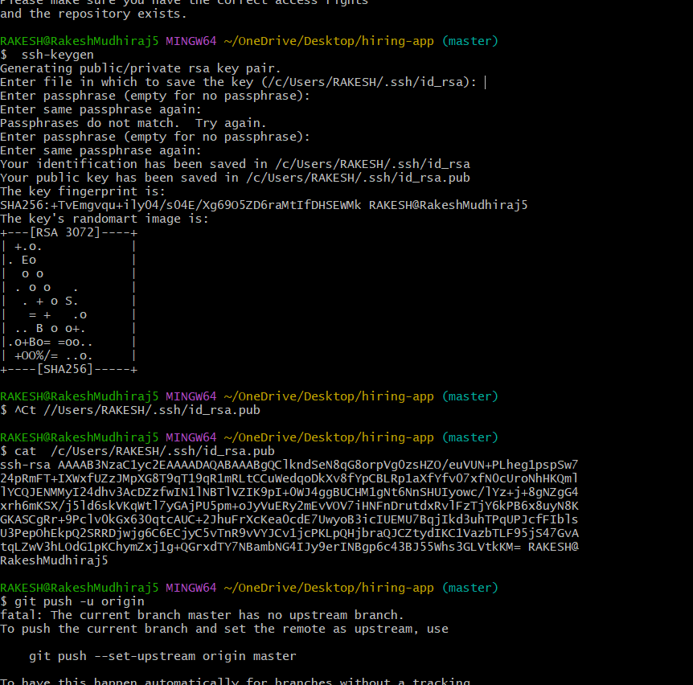
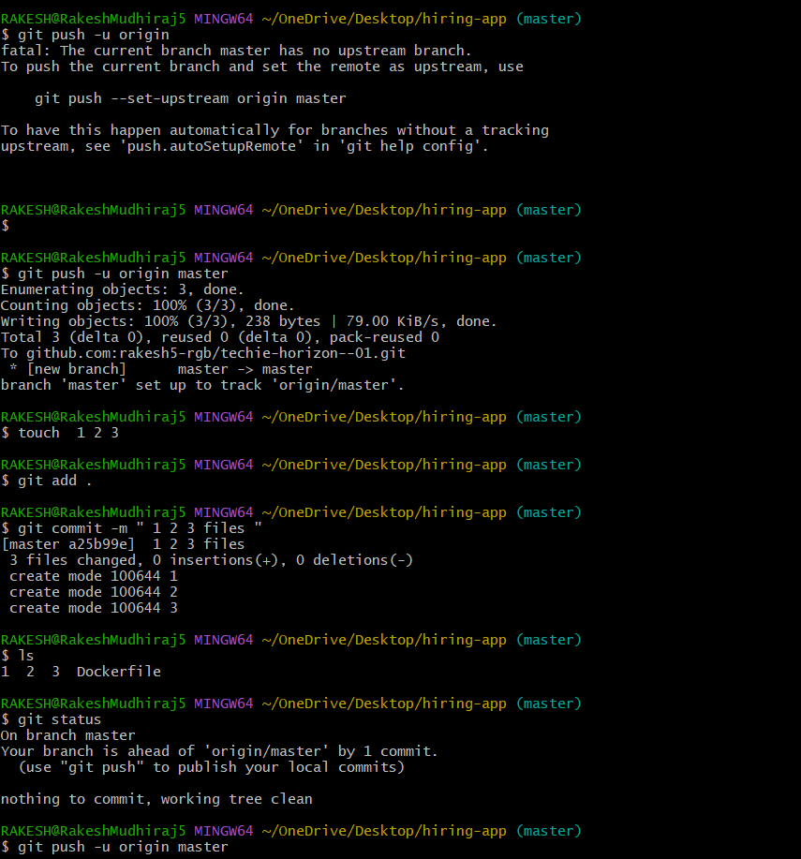
git clone : is used to download a complete copy of a remote repository (from platforms like GitHub) to your local machine.

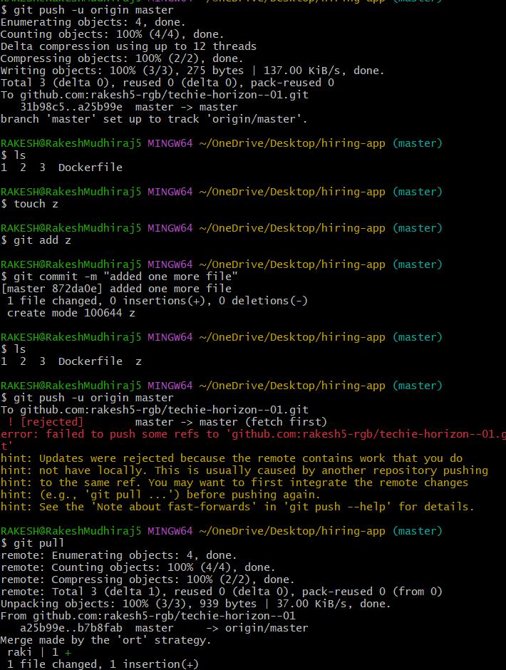

git revert log id: is used to undo a specific commit by creating a new commit that reverses the changes.

